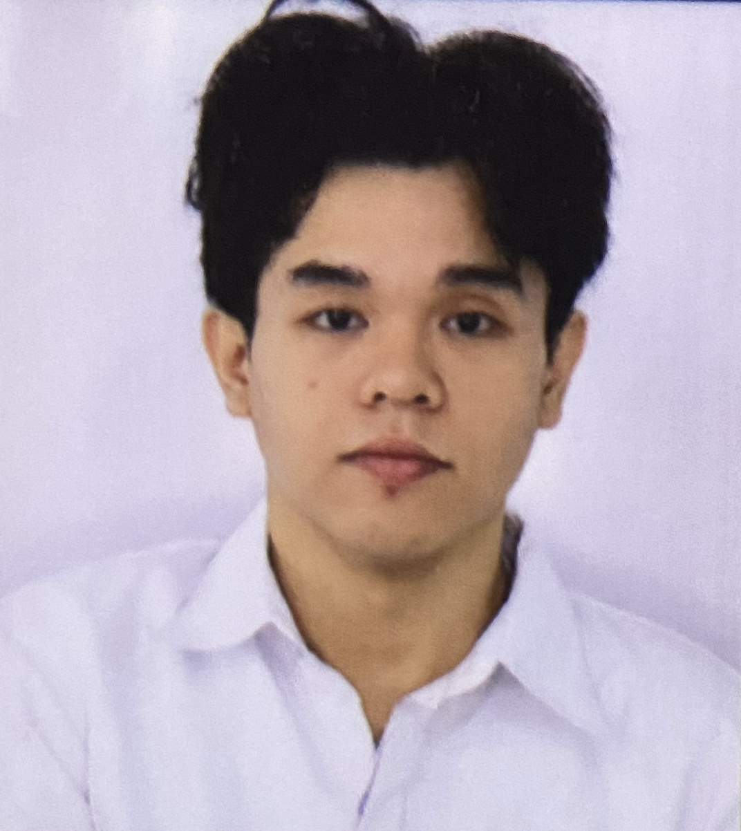
DWEN LYSTEE RAMOS ROJAS
Hilongos, Leyte
dwenlysteerojas@gmail.com
09648689791
PROFESSIONAL SUMMARY
Motivated Bachelor of Science in Information Technology student with experience in web development, UI/UX design, and software development. Passionate about solving problems through technology and eager to contribute to an innovative organization while continuously developing technical and professional skills.
——————————————————————————————————————
WORK EXPERIENCE
Information Technology Intern
Maasin City Hall
- Assisted in IT-related tasks and administrative operations.
- Provided technical support and maintained digital records.
GoTyme Bank Intern
- Supported daily operations and customer service.
- Maintained professionalism in banking operations.
EDUCATION
Bachelor of Science in Information Technology
The College of Maasin
Expected Graduation: AY 2027–2028
GPA: 1.40
KEY ACHIEVEMENTS
- Completed multiple responsive web development projects.
- Served in the Supreme Student Council for two years.
- Served as Department Officer for one year.
- Volunteer, Philippine Red Cross.
SKILLS
Core Skills: Communication, Leadership, Teamwork, Time Management, Critical Thinking, Adaptability
Technical Skills: HTML, CSS, JavaScript, Python, UI/UX Design, Web Development
PROJECTS
- Personal Portfolio Website
- K-Pop Streaming Platform
- Movie Streaming Platform
- Apple Store-Inspired Website
LEADERSHIP & VOLUNTEER EXPERIENCE
Supreme Student Council Officer (2 Years)
Department Officer (1 Year)
Philippine Red Cross Volunteer
_____________________________________________________________________
REFERENCE
Jason Balbarona
Chief of Police, Maasin City Police Station

